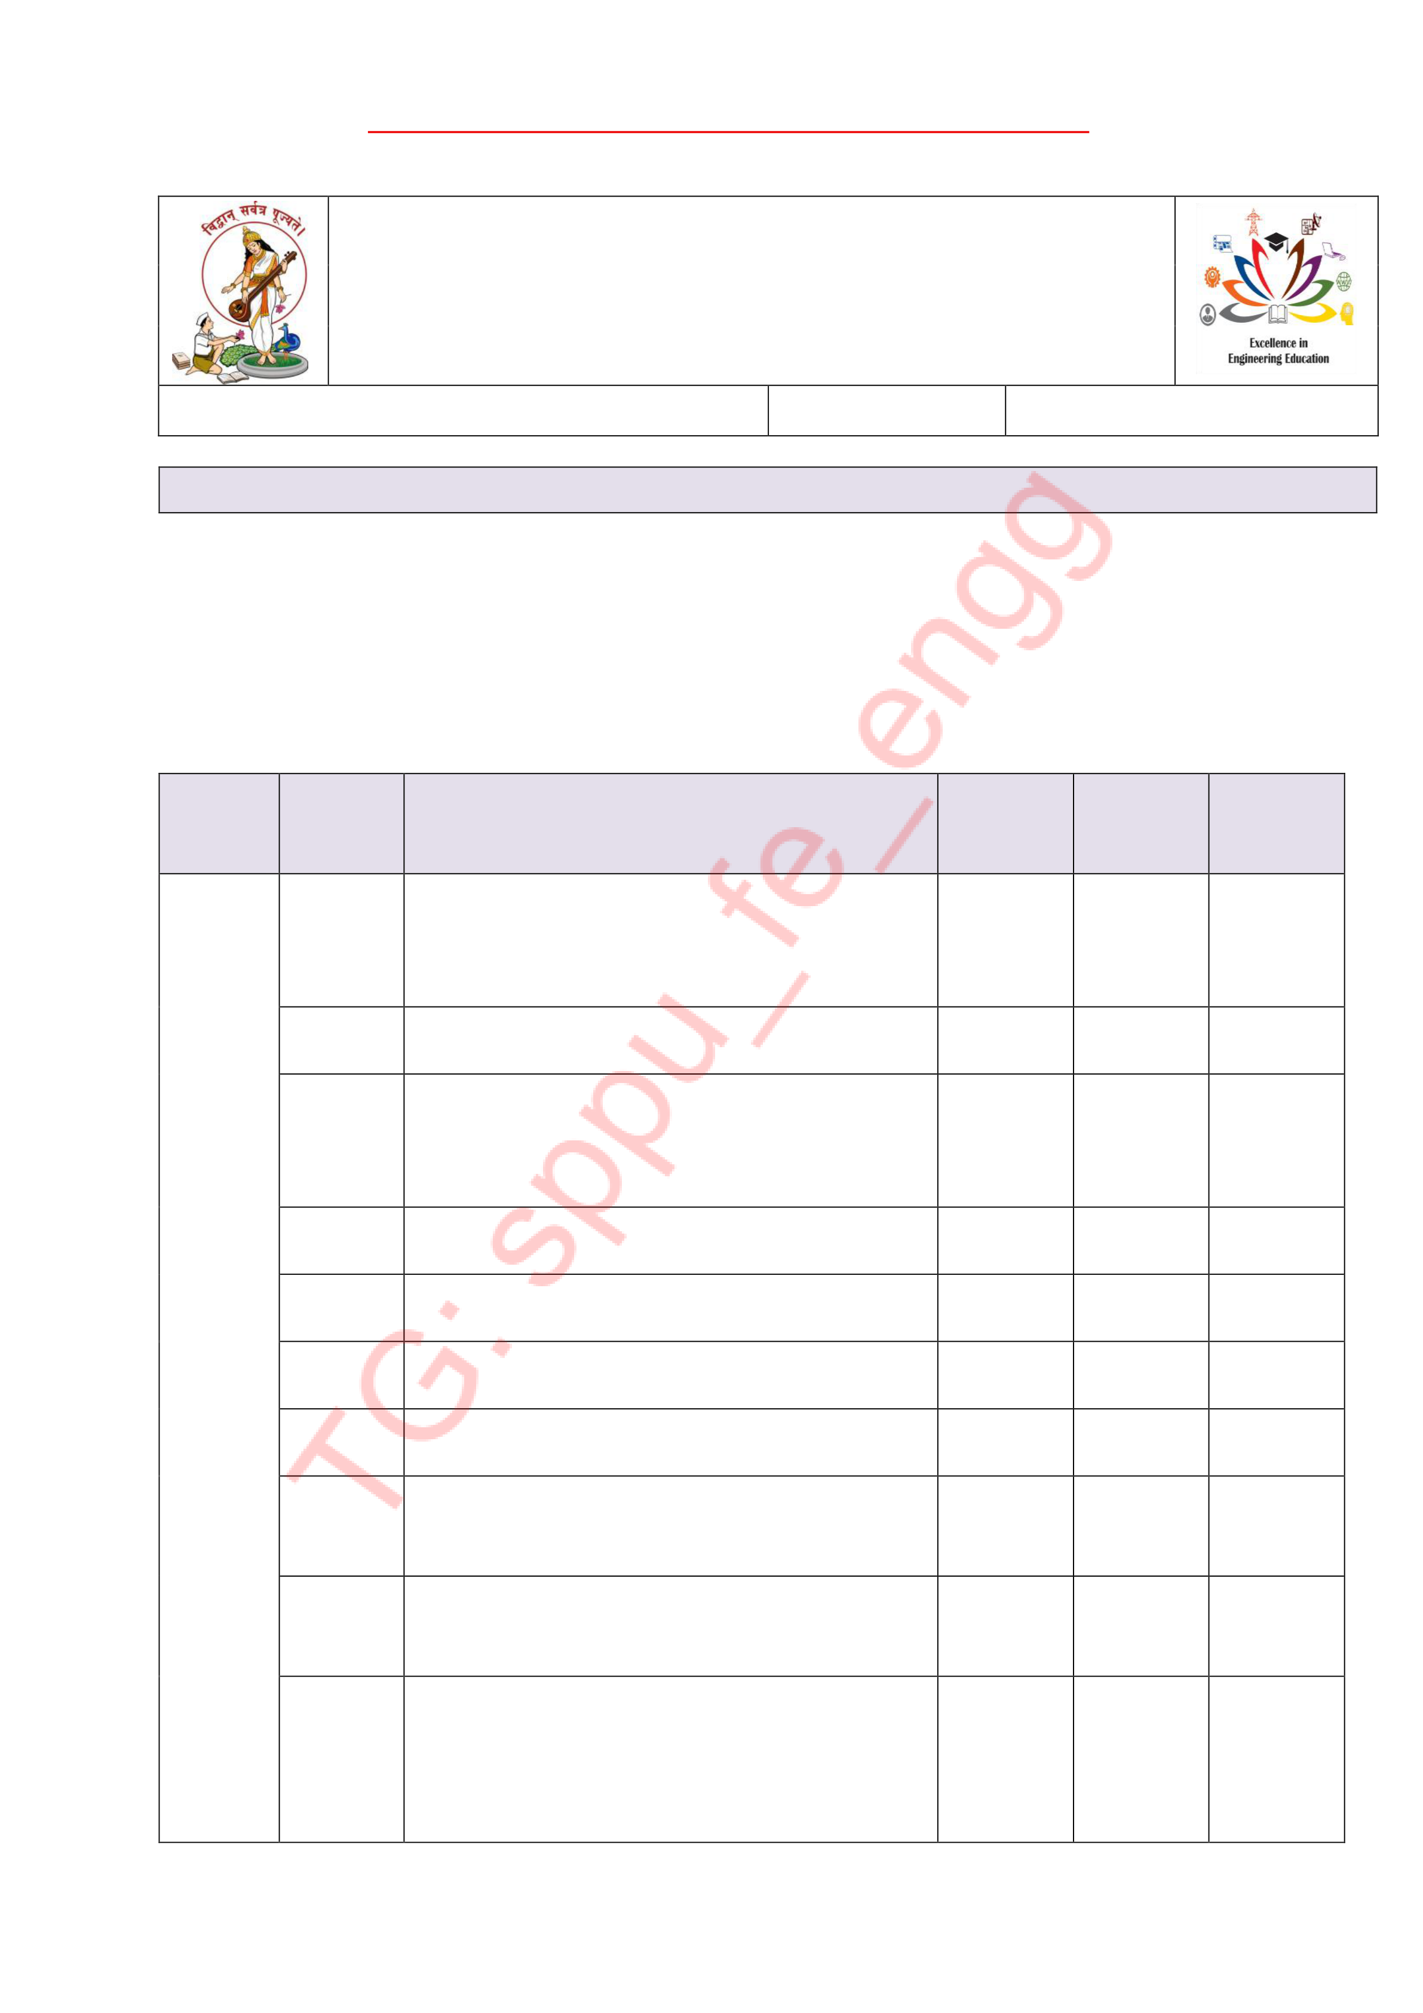

Pune Vidyarthi Griha’s
COLLEGE OF ENGINEERING, TECHNOLOGY AND MANAGEMENT, PUNE-09
Record No.: PVGCOETM/QMS/ACAD/R/46 |  | Revision: 00 | Date:1/7/2025

Unit Wise Question Bank
Department: Computer Semester: I Academic Year: 2025 - 2026

Class:SE Div: Course: Data Structure

Date:13/09/2025

Unit  No. -  name | Q. No. | Question | Marks | CO | Blooms Level
1- | Q.1 | Define and explain the following terms: (i) Data (ii ) Data structure  (iii) Flowchart. | 6 | 1
1- | Q.2 | Define algorithms and explain its characteristics | 6 | 1
1- | Q.3 | Explain the divide and conquer strategy  with suitable example. Comment on its time complexity. | 6 | 1
1- | .Q.4 | Explain the Asymptotic notation Big O, Omega and Theta with suitable example | 6 | 1
1- | .Q.5 | Explain static and dynamic data structures with examples. | 6 | 1
1- | Q.6 | Differentiate between linear and non-linear data structure with example | 6 | 1
1- | Q.7 | Explain the Greedy strategy with suitable example. Comment on its time complexity | 6 | 1
1- | Q.8 | Define and explain ADT (Abstract Data Type). | 6 | 1
1- | Q.9 | State Analysis of programming constructs - Linear, Quadratic, Cubic, Logarithmic | 6 | 1
1- | Q.10 | . Define and explain the following terms: (a) Linear data structure  (b) Non-linear data structure  (c) Time complexity  (d) Space complexity | 6 | 1

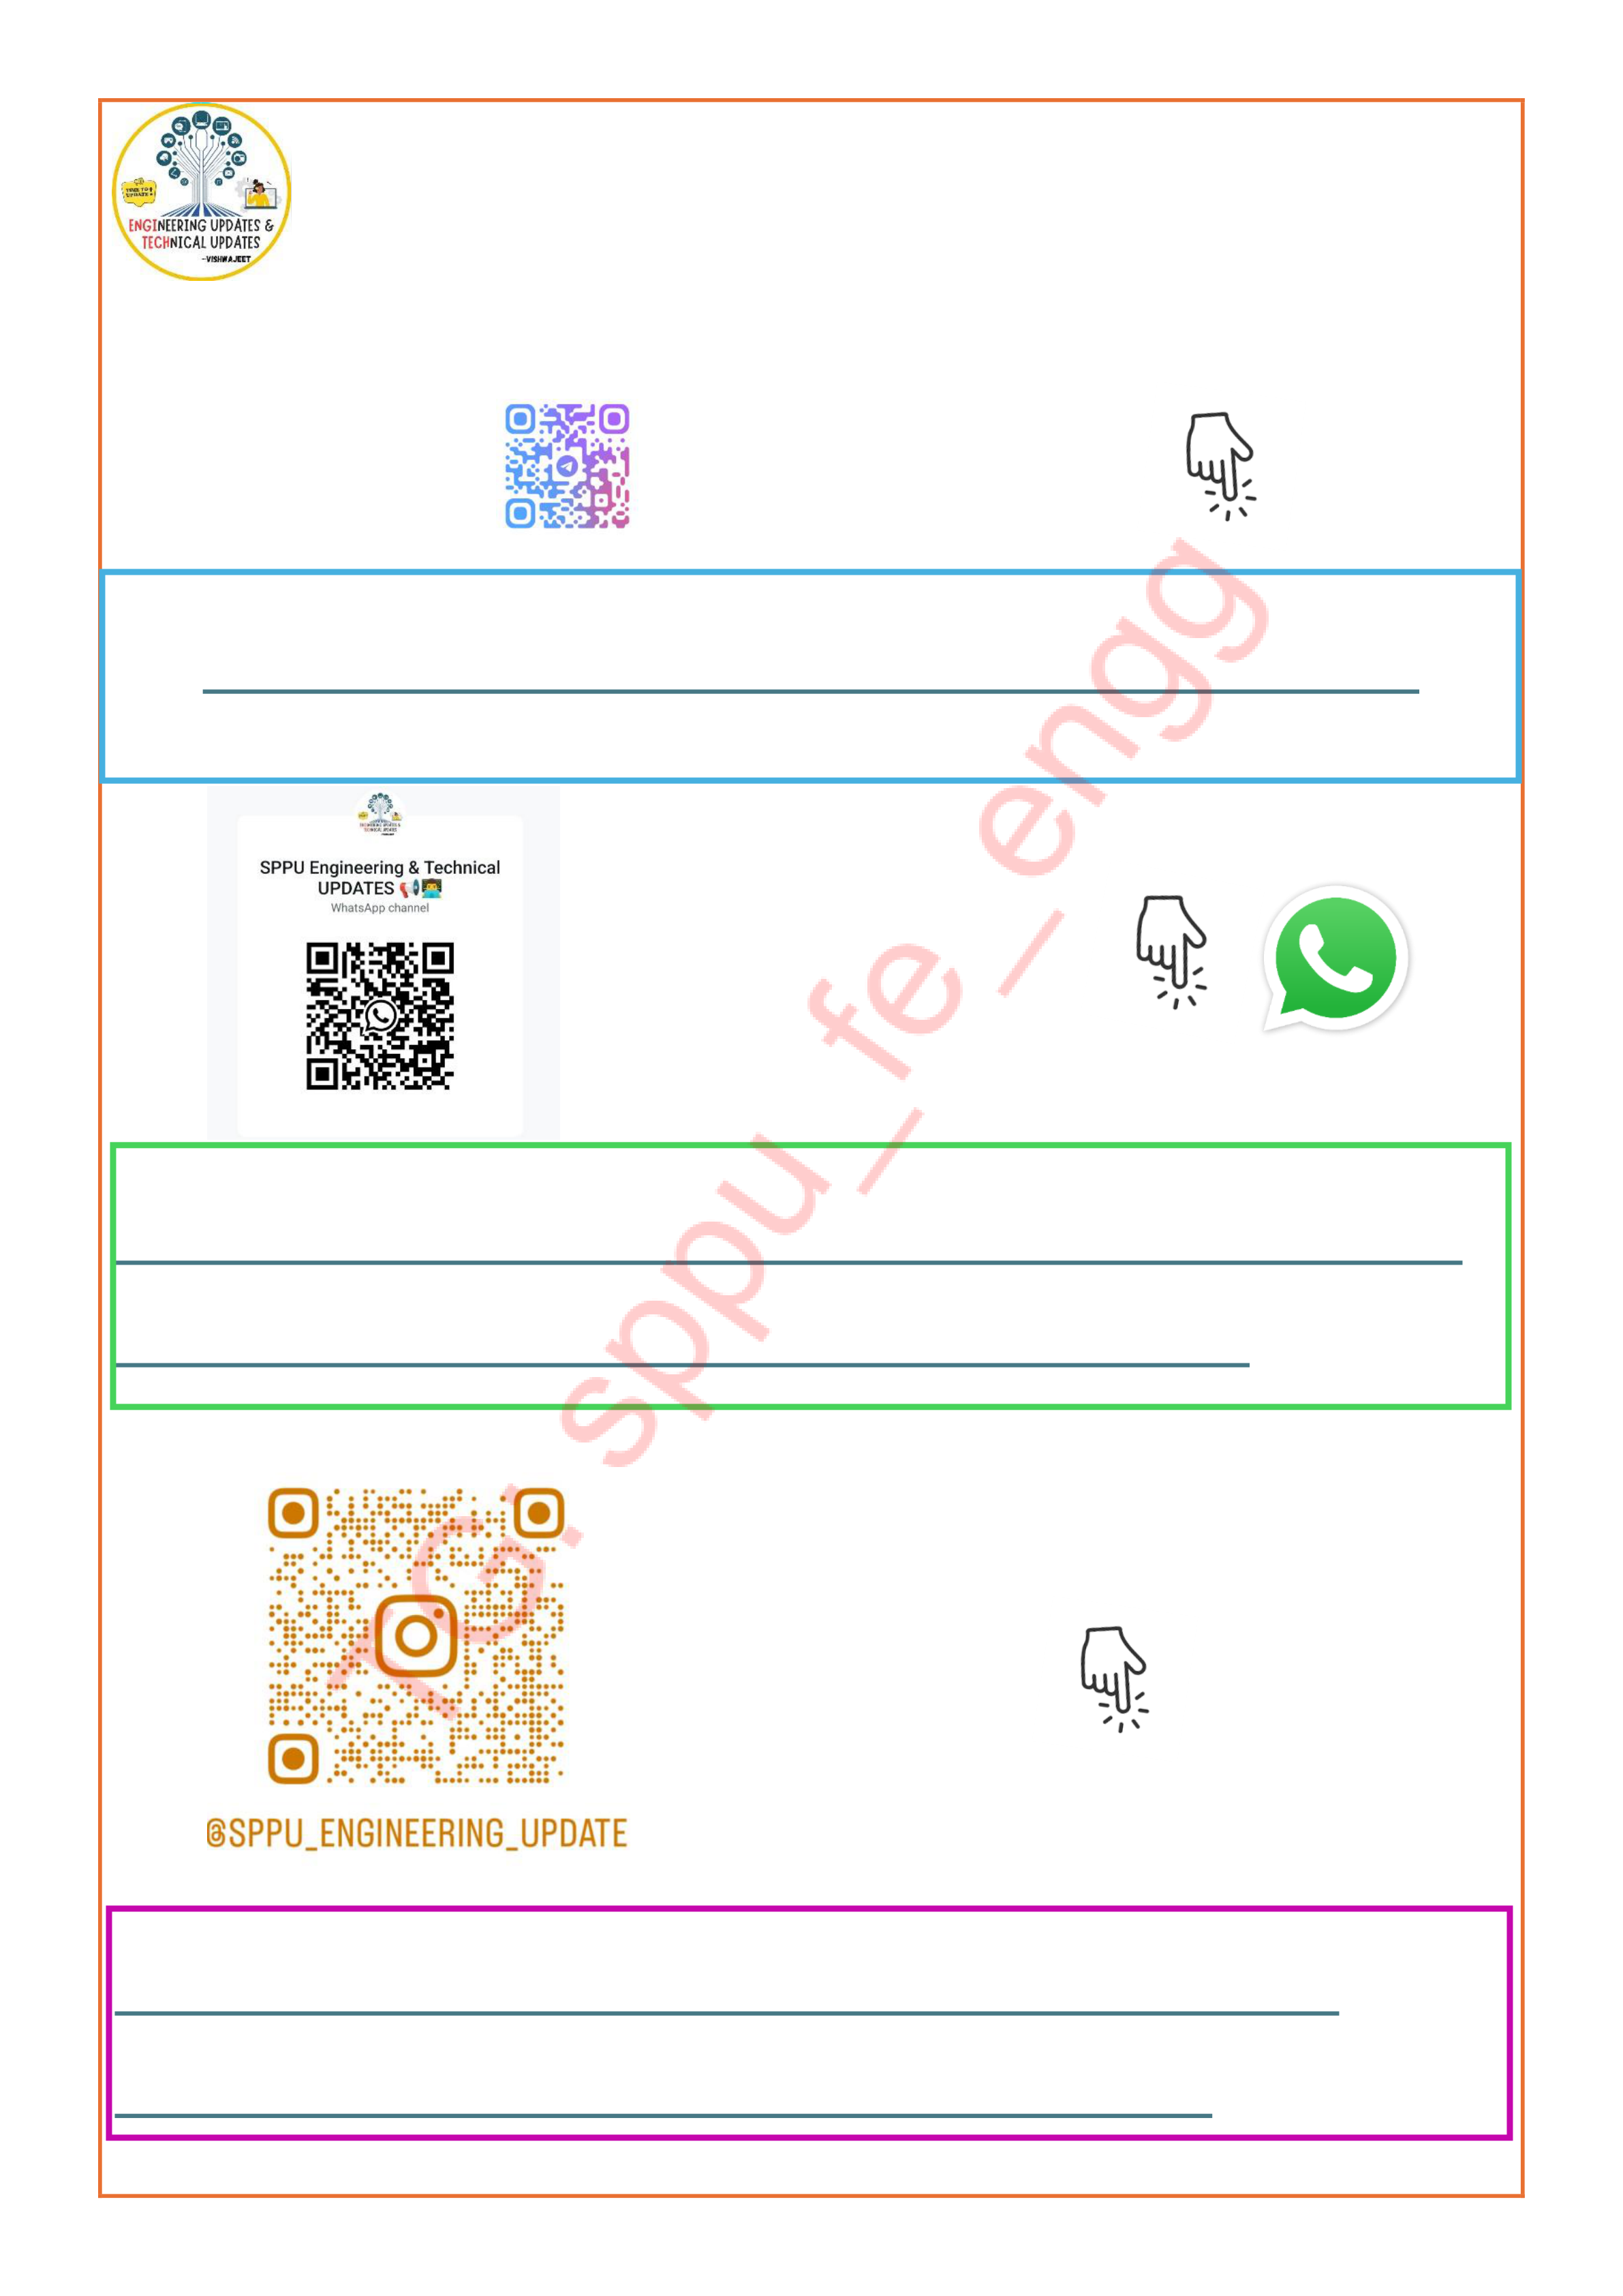
(for all engineering Resources)
https://whatsapp.com/channel/ 0029ValjFriICVfpcV9HFc3b

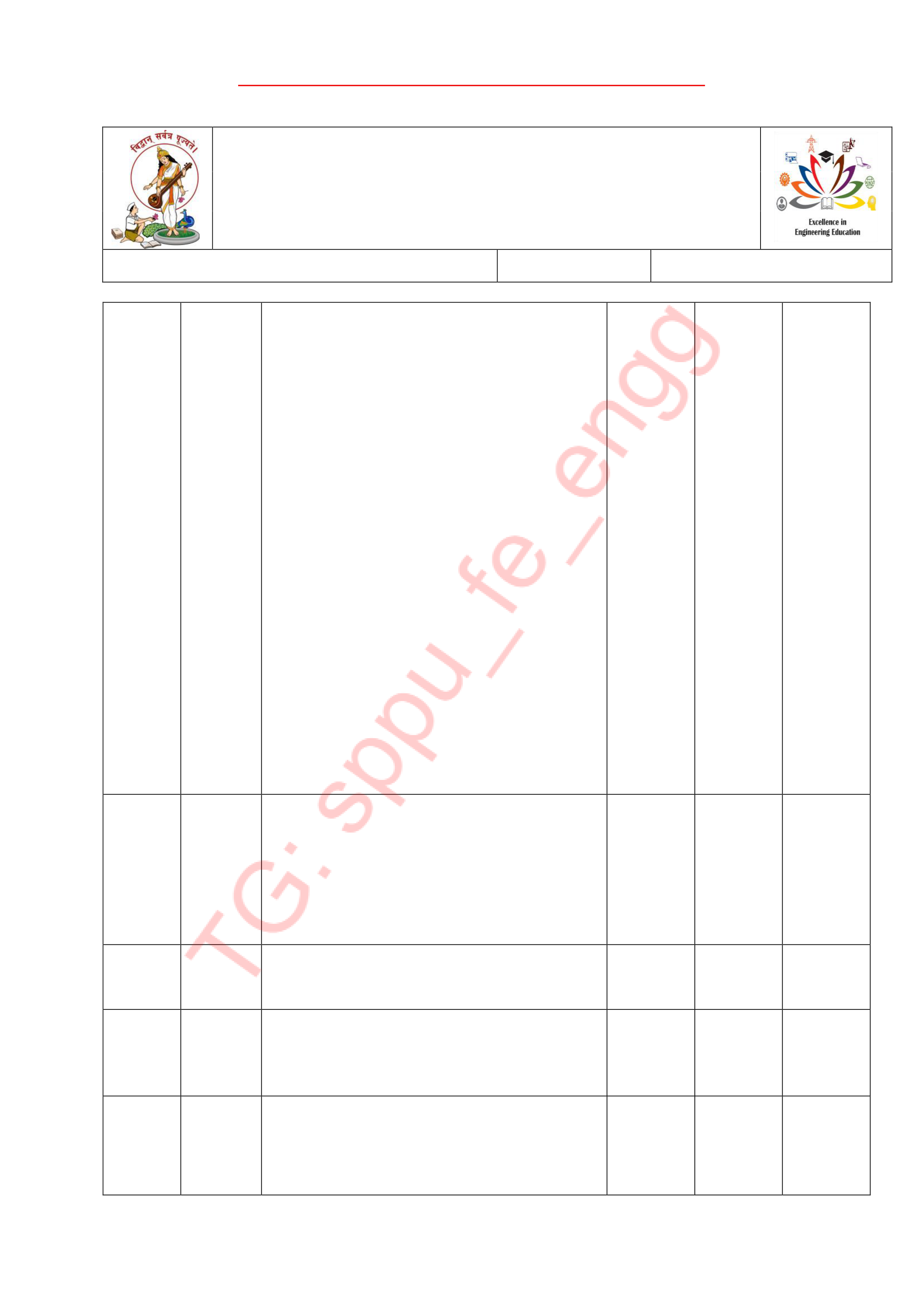

Pune Vidyarthi Griha’s
COLLEGE OF ENGINEERING, TECHNOLOGY AND MANAGEMENT, PUNE-09
Record No.: PVGCOETM/QMS/ACAD/R/46 |  | Revision: 00 | Date:1/7/2025

 | Q.11 | Analyse time complexity of following codes. Show step count for each  statement: [6]  i) function is Prime(n){  for (i=2;i<n;++i){  if (n%i= = = 0){  return false;  }  }  return true;  }  ii) Function f()  {  ans=0  for (i=n;i>=1;i/=2){  for (j=1; j <=m; j*=2){ ans+= (i*j)  }  print(ans)  } | 6 | 1
 | Q.12 | Write short note on.  1.ADT  2. Divide and conquer  3.greedy strategies.  4.array  5.space complexity.  6.Time complexity | 6 | 1
 | Q.13 | What is mean by algorithm? Explain the characteristics of  algorithm | 6 | 1
 | Q.14 | Differentiate between linear and non-linear data structures with examples. | 6 | 1
 | Q.15 | What is the time complexity? why asymptotic notations are important?find time complexity of the following code using step count method. | 6 | 1

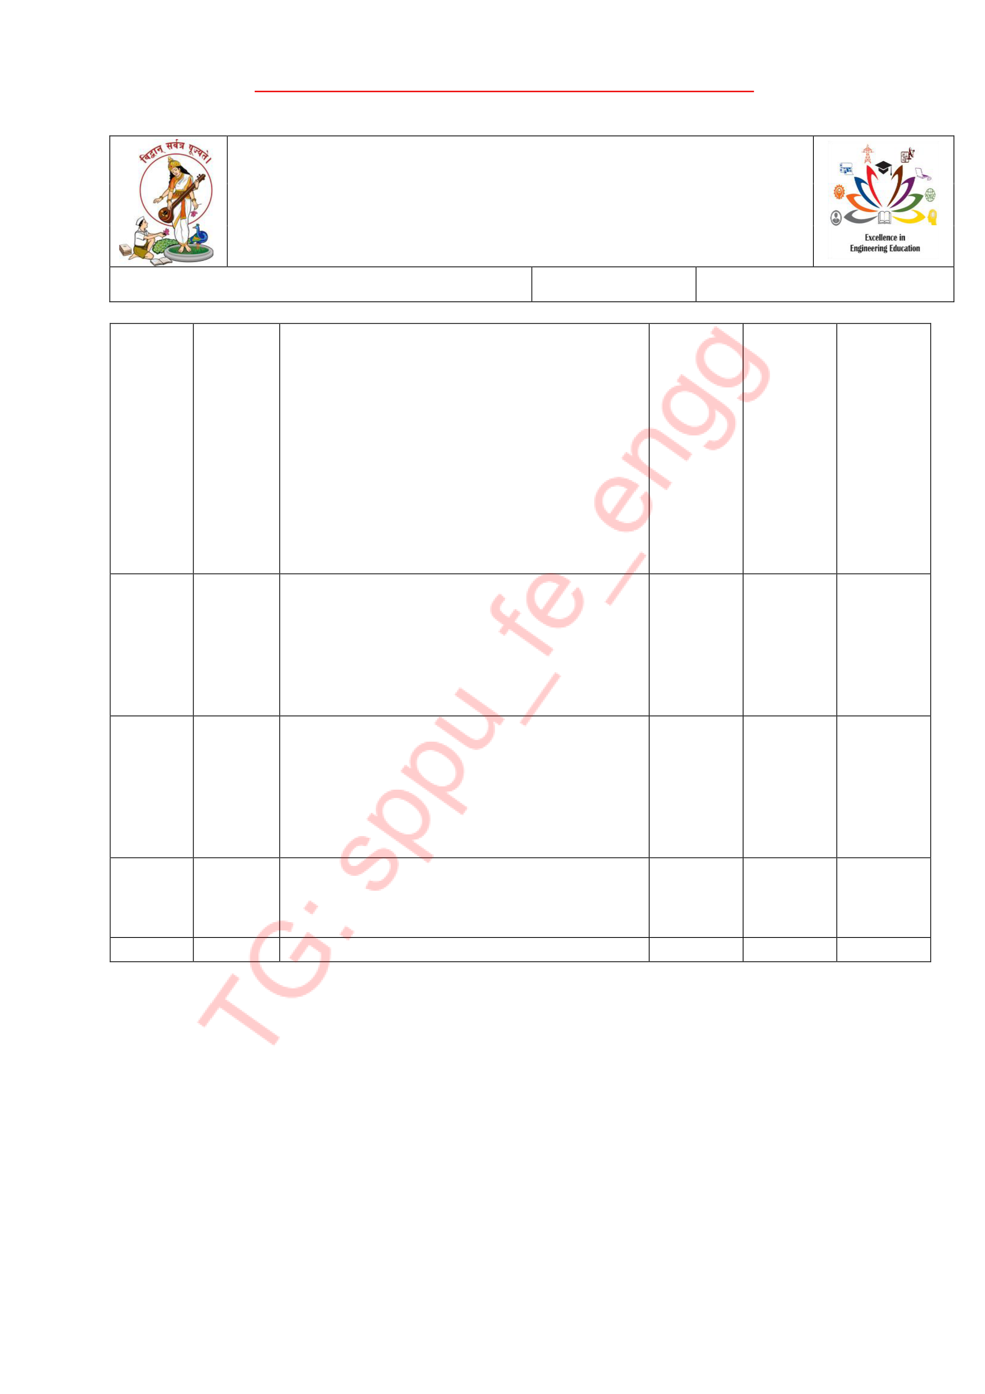

Pune Vidyarthi Griha’s
COLLEGE OF ENGINEERING, TECHNOLOGY AND MANAGEMENT, PUNE-09
Record No.: PVGCOETM/QMS/ACAD/R/46 |  | Revision: 00 | Date:1/7/2025

int x=0;
for(i=0;i<N;i++)
{
for (j=N;j>i;j--)
{
x=x+i+j;
}
}
 | Q.16 | Write short Note on:  i)ADT  ii)Divide and conquer strategy. | 6 | 1
 | Q.17 | Differentiate between:  i)static and dynamic data structure  Ii) Persistent and ephemeral data structure | 6 | 1
 | Q.18 | Explain step count method with the help of example. | 6 | 1
Course Teacher

